**Chronic pain and mental health: Breaking the cycle**

**The hidden impact of chronic pain**

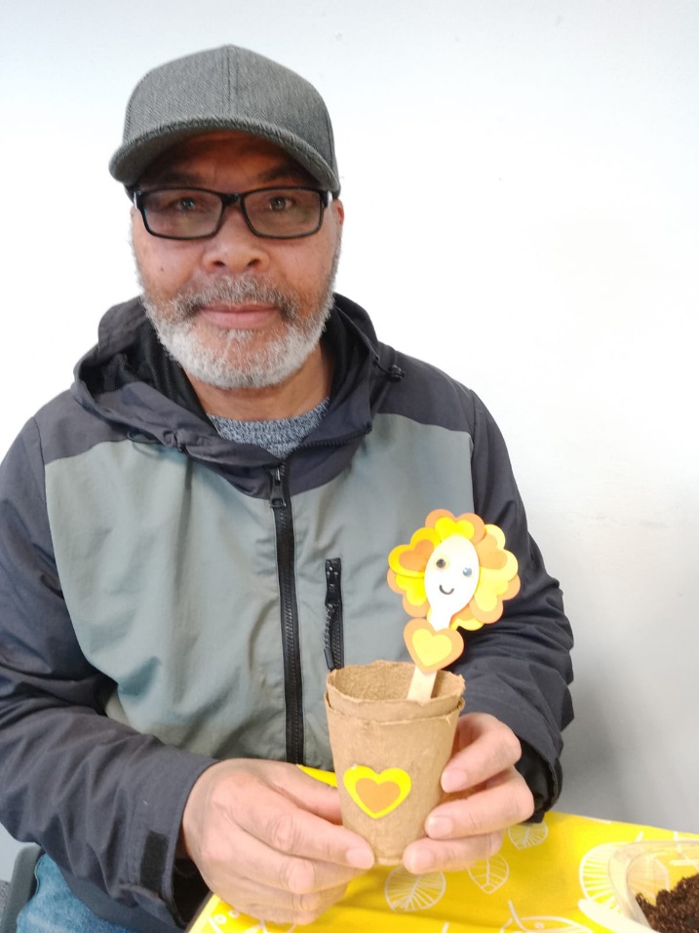

Chronic pain doesn’t just affect the body – It takes a toll on mental health too. Many people living with long-term pain experiences **stress, anxiety, depression, and feeling of isolation**. The constant struggle to manage pain can lead to frustration, low moo, and even loss of identity.

At our **pain cafes and clinics**, we see how deeply connected pain and mental well-being are. This month we’ve had some powerful discussions on how pain affects emotions, and more importantly, what can help break the cycle.

**What patients are saying**

Many people attending our sessions have shared how pain affects their mental well-being:

* “I used to love socializing, but now I cancel plans because I don’t know how I’ll feel that day. It’s lonely.”
* “Some days the pain is so bad that it’s not just physical – it’s mentally exhausting.”
* “I’m struggling to explain my pain to others, and sometimes I feel like no one understands.”

These experiences are real and valid, and they highlight why support is so important.

**How pain and mental health are linked**

Chronic pain and mental health often feed into each other, creating a **cycle that’s hard to break:**

1. **Pain increases stress an anxiety,** leading to tension and worsening pain.
2. **Low mood reduces motivation,** to engage in movement or self-care.
3. **Sleep problems become common,** making pain feel even worse the next day.
4. **Lack of understanding from others** can lead to frustration, isolation and emotional exhaustion.

Breaking this cycle isn’t easy, but small, **consistent** changes can make a difference.

**What’s helping people cope?**

Through our sessions, we’ve discussed several approaches that patients have found helpful:

* **Mindfulness & relaxation** – learning how to calm the nervous system through deep breathing, meditation, or simple relaxation exercises can ease both pain and stress.
* **Gentle movement** – While exercise can feel daunting, small movements, stretching or even walking can **release tension and boost mood**.
* **Talking & sharing** – whether it’s in a pain café, with a therapist, or a trusted friend, talking about pain and emotions **can reduce feelings of isolation.**
* Pacing & prioritising – Learning to balance activity and rest helps prevent burnout and frustration.

**You’re not alone**

If you’re struggling with both **chronic pain** and your **mental health**, know you’re not alone. There’s no single solution, but **finding the right support, learning new coping strategies, and connecting with others who understand can make a real difference**.

We’d love to see you at one of our upcoming pain cafés or clinics. If you’d like to join, or if you have ideas on how we can make these sessions more helpful, please get in touch!

Together we can learn, share and support each other – because **chronic pain and mental health deserve equal attention.**